Running a Service Audit Report: This topic covers how to print a Service Audit Report, both from Repair Order Maintenance (ROM) and from Repair Order History (ROH).

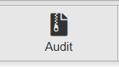

ROM Audit Button: This button (pictured above) is located just below the header in ROM. Clicking on it when you have an Open repair order on the screen produces a PDF report for all activity for the specific repair order.
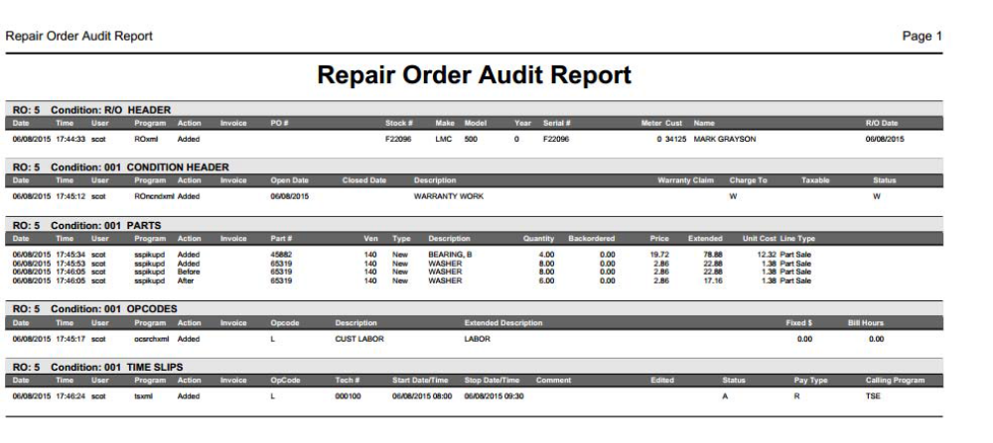
Report Features:

- Each time a new entry, change, or deletion occurs, there will be a time-stamped entry which includes the login and activity performed.
- Each segment of the RO has a section in this reporting function which keeps the entire timeline for that RO.
- The report includes tracking for Technician Time Slips, Parts, Sublets, Other Charges, and the completion of the RO.
- Using this report in conjunction with the Time Slip Report (TSR) will provide complete tracking of all activity on the RO including the people responsible for the data entries or changes.

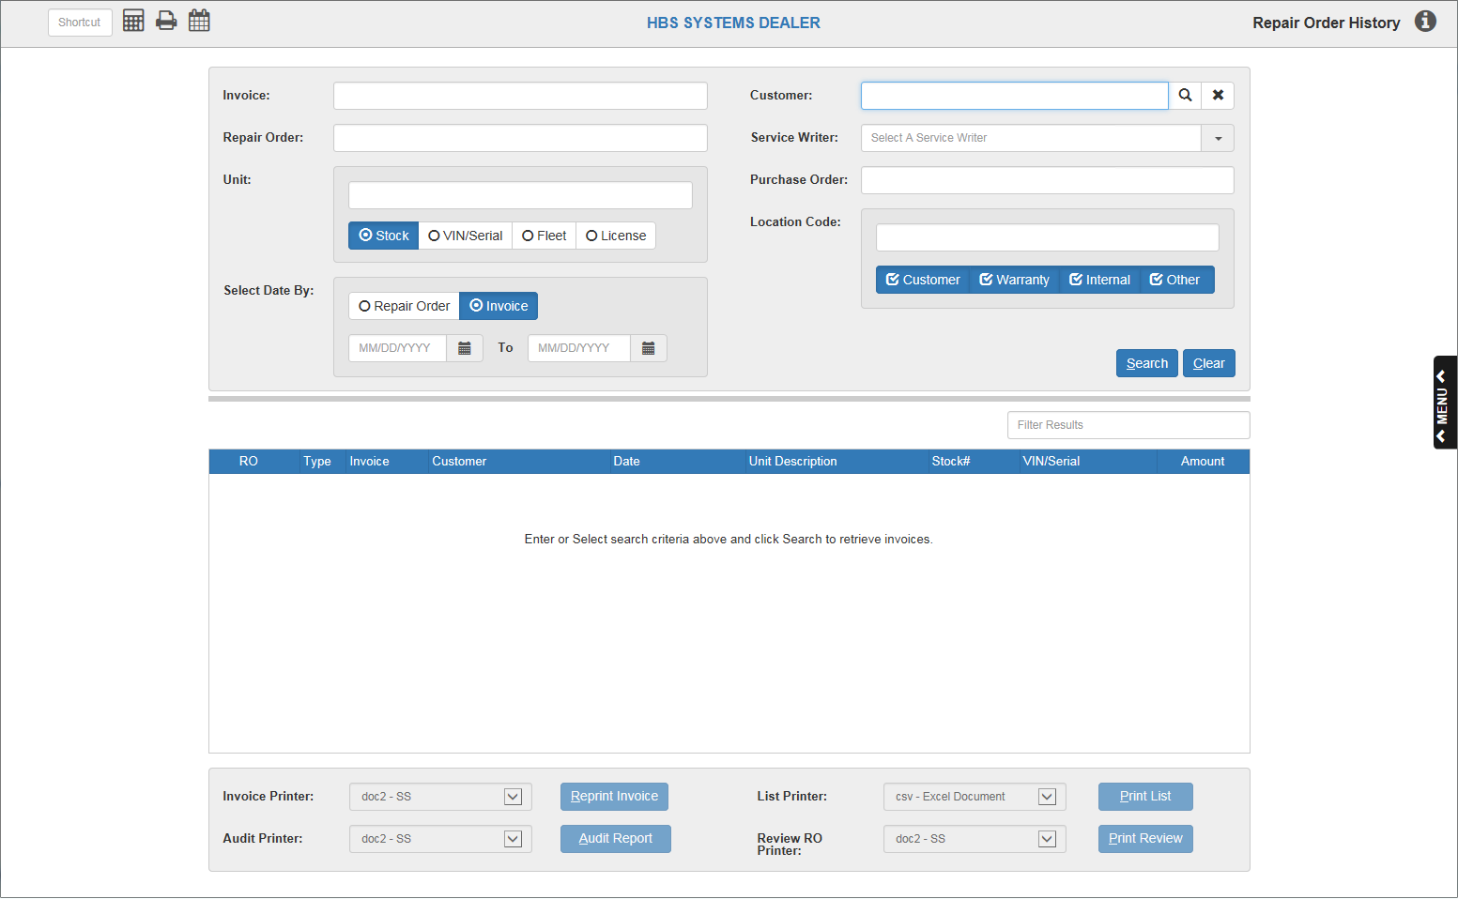

Audit Reports In ROH: An  button is also available in ROH and shows as soon as an RO is selected there. This allows you to create a complete Service Audit Report for historical Closed orders stored. Choose the Audit Printer you want from the drop-down menu and click the button to create the Audit Report.

